 Menu March 9th-13th
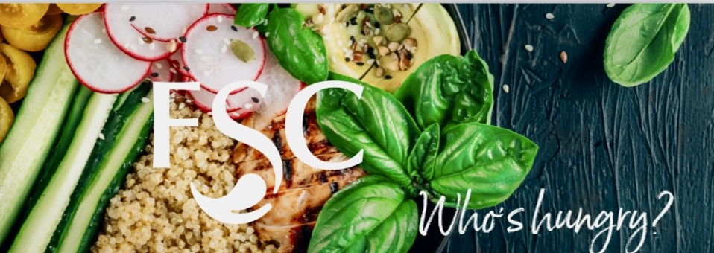
Daily Offerings
Fresh & Healthy
Yogurt Parfait
Fresh Cut Fruit
Apple Slices with Peanut Butter
Layered Trifle Cups
Salad of the Day
Wrap of the Day
Deli Sandwich of the Day

Daily Hot Sandwiches
Classic ¼ Pound Burgers
Hand Breaded Spicy Chicken
Crispy Chicken Club
Marinated Grilled Chicken
Bernice’s Daily Special

Snacks & Baked Goods
Classic Chips & Baked Chip Selections
America's Favorites Candy Selections
Fresh Baked Signature Cookies
Ice Cream Novelties

Beverages
Pepsi Products
Naked Juice
Muscle Milk

Please contact
Café Manager
Bernice Snyder
110manager@foodserv.org

Lee Gustin
District Supervisor
8534 Watson Rd St. Louis, Mo 63119
foodserviceconsultants.org
lee@foodserv.org
Mobile: (618) 789-1425
MENU IS SUBJECT TO CHANGE
Contact our dietitian at lisa@foodserv.org for special dietary and allergy concerns.
For more information about FSC or employment opportunities, please go to www.foodserviceconsultants.org

Monday
Brio – Lasagna & Bread Stick
Homestyle Fresh – Cannelloni Bites
Sides- French Fries
Vegetarian Entree – Cheese Tortellini w/ Cheese Sauce

Tuesday
Brio – Street Tacos
Homestyle Fresh – Chicken Chimichanga w/ Spanish Rice
Sides- French Fries
Vegetarian Entree – Queso Dip & Tortilla Chips

Wednesday
Brio – Mac & Cheese Bar
Homestyle Fresh – Chicken Bites
Sides- French Fries
Vegetarian Entree – Grilled Cheese

Thursday
Brio -Cowboy Nacho Bar
Homestyle Fresh -Orange Chicken w/ Rice
Sides- French Fries
Vegetarian Entree – Stir-Fried Veggies and Rice

Friday
Brio – Baked Potato Bar
Homestyle Fresh -Fried Shrimp, Grilled Cheese, Soft Pretzels, Tomato Soup
Nacho Cheese Toasted Ravioli, Egg and Cheese Bagels
Sides- French Fries
Vegetarian Entree – Personal Pan Cheese Pizza


