 Menu March 23rd-27th
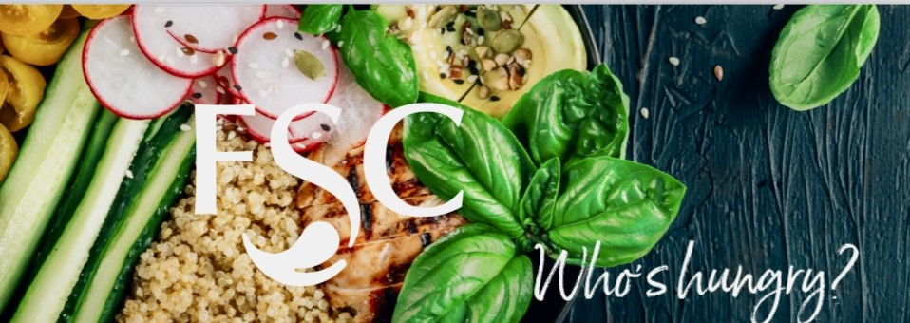
Daily Offerings
Fresh & Healthy
Yogurt Parfait
Fresh Cut Fruit
Apple Slices with Peanut Butter
Layered Trifle Cups
Salad of the Day
Wrap of the Day
Deli Sandwich of the Day

Daily Hot Sandwiches
Classic ¼ Pound Burgers
Hand Breaded Spicy Chicken
Crispy Chicken Club
Marinated Grilled Chicken
Bernice’s Daily Special

Snacks & Baked Goods
Classic Chips & Baked Chip Selections
America's Favorites Candy Selections
Fresh Baked Signature Cookies
Ice Cream Novelties

Beverages
Pepsi Products
Naked Juice
Muscle Milk

Please contact
Café Manager
Bernice Snyder
110manager@foodserv.org

Lee Gustin
District Supervisor
8534 Watson Rd St. Louis, Mo 63119
foodserviceconsultants.org
lee@foodserv.org
Mobile: (618) 789-1425
MENU IS SUBJECT TO CHANGE
Contact our dietitian at lisa@foodserv.org for special dietary and allergy concerns.
For more information about FSC or employment opportunities, please go to www.foodserviceconsultants.org

Monday
Brio – Pasta w/ Bread Stick
Homestyle Fresh – St Louis Burnt Ends w/ Cornbread
Sides- French Fries
Vegetarian Entree – Toasted Cheese Ravioli

Tuesday
Brio – Taco Bowl
Homestyle Fresh – Big Bacon Grilled Cheese w/Chips
Sides- French Fries
Vegetarian Entree – Tomato Soup

Wednesday
Brio – Baked Potato Bar
Homestyle Fresh – Chicken Rings
Sides- French Fries
Vegetarian Entree – Spicy Cheese Curds

Thursday
Brio -Cowboy Nacho Bar
Homestyle Fresh -General Tso’s Chicken w/ Rice
Sides- French Fries
Vegetarian Entree – Stir-Fried Veggies and Rice

Friday
Brio – Mac & Cheese Bar
Homestyle Fresh -Fried Shrimp, Grilled Cheese, Tomato Soup
Crab Rangoon, Soft Pretzels, Nacho Cheese Ravioli, Mozzarella Cheese Stick
Sides- French Fries
Vegetarian Entree – Personal Pan Cheese Pizza


