 Menu March 2-6,2026
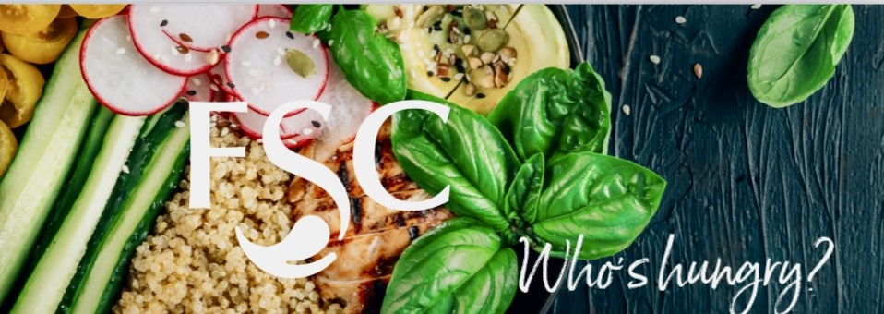
Daily Offerings
Fresh & Healthy
Yogurt Parfait
Fresh Cut Fruit
Apple Slices with Peanut Butter
Layered Trifle Cups
Salad of the Day
Wrap of the Day
Deli Sandwich of the Day

Daily Hot Sandwiches
Classic ¼ Pound Burgers
Hand Breaded Spicy Chicken
Crispy Chicken Club
Marinated Grilled Chicken

Snacks & Baked Goods
Classic Chips & Baked Chip Selections
America's Favorites Candy Selections
Fresh Baked Signature Cookies
Ice Cream Novelties

Beverages
Pepsi Products
Naked Juice
Muscle Milk

Please contact
Café Manager
Bernice Snyder
110manager@foodserv.org

Lee Gustin
District Supervisor
8534 Watson Rd St. Louis, Mo 63119
foodserviceconsultants.org
lee@foodserv.org
Mobile: (618) 789-1425
MENU IS SUBJECT TO CHANGE
Contact our dietitian at lisa@foodserv.org for special dietary and allergy concerns.
For more information about FSC or employment opportunities, please go to www.foodserviceconsultants.org

Monday
Brio – Pasta & Bread Stick Dips
Homestyle Fresh – Pizza Quesadilla
Sides- French Fries
Vegetarian Entree – Mac & Cheese
Tuesday
Brio - Taco Bowl
Homestyle Fresh -Nashville Hot Chicken
Sides- French Fries
Vegetarian Entree - Mozzarella Cheese Sticks
Wednesday
Brio – Waffle Bar
Homestyle Fresh – Pulled Pork Sandwich
Sides- French Fries
Vegetarian Entree – Grilled Cheese
Thursday
Brio -Cowboy Nacho Bar
Homestyle Fresh -Mini Tacos
Sides- French Fries
Vegetarian Entree - Buttered Egg Noodles
Friday
Brio – Baked Potato Bar
Homestyle Fresh -Fried Shrimp, Bosco Stick, Grilled Cheese, Tomato Soup, Crab Rangoon, Cheese Pizza, Soft Pretzels
Sides- French Fries, Butter Noodle
Vegetarian Entree – Toasted Cheese Ravioli, Mozzarella Cheese Stick c


