 Menu December 8th-12th
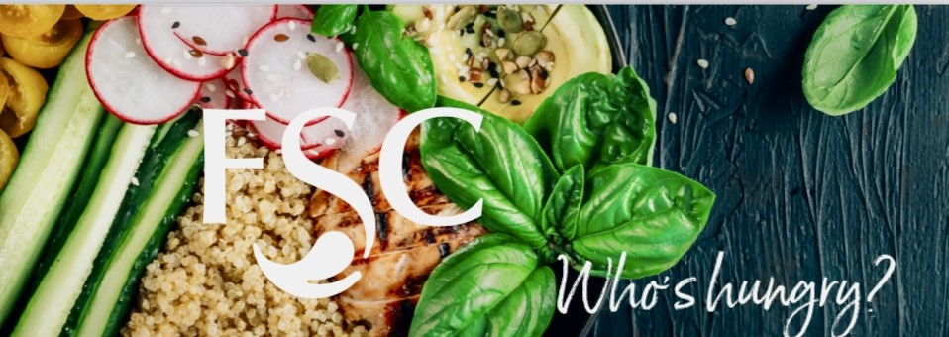
Daily Offerings
Fresh & Healthy
Yogurt Parfait $3.05
Fresh Cut Fruit $3.05
Lunch Box $ 5.50
Layered Trifle Cups $3.05
Salad of the Day $5.25
Wrap of the Day $4.20
Deli Sandwich of the Day $3.90
Daily Hot Sandwiches
Classic ¼ Pound Burgers $ 4.70
Classic ¼ Pound Burgers W/ Cheese $5.00
Hand Breaded Spicy Chicken $5.80
Crispy Chicken Club $6.05
Marinated Grilled Chicken $ 4.70
Bernice’s Daily Special
Snacks & Baked Goods
Classic Chips & Baked Chip Selections $1.60
America's Favorites Candy Selections $2.90
Movie Theater Candy $3.90
Fresh Baked Signature Cookies $1.95
Ice Cream Novelties 3.25
Soft Serv Sundae $ 2.45 w/ Topping $3.60
Beverages
Pepsi Products $3.05
Propel Water $3.05
Energy Drinks $4.50
Milk $3.00
Starbucks $5.00
Please contact
Café Manager
Bernice Snyder
110manager@foodserv.org

Lee Gustin
District Supervisor
8534 Watson Rd St. Louis, Mo 63119
foodserviceconsultants.org
lee@foodserv.org
Mobile: (618) 789-1425
MENU IS SUBJECT TO CHANGE
Contact our dietitian at lisa@foodserv.org for special dietary and allergy concernsemployment opportunities, please go to www.foodserviceconsultants.org

Monday
Brio – Lasagna & Bread Stick $7.30
Homestyle Fresh – Cannelloni Bites $6.00
Sides- French Fries $3.00
Vegetarian Entree – Cheese Tortellini w/ Cheese Sauce $4.95

Tuesday
Brio – Street Tacos $7.30
Homestyle Fresh – Chicken Chimichanga w/ Spanish Rice $6.00
Sides- French Fries $3.00
Vegetarian Entree – Queso Dip & Tortilla Chips $3.95

Wednesday
Brio – Baked Potato Bar $7.30
Homestyle Fresh – Chicken Bites $6.00
Sides- French Fries $3.00
Vegetarian Entree – Grilled Cheese $3.95

Thursday
Brio -Cowboy Nacho Bar $7.30
Homestyle Fresh -Orange Chicken w/ Rice $6.00
Sides- French Fries $3.00
Vegetarian Entree – Stir-Fried Veggies and Rice $3.95

Friday
Brio – Chili Mac & Tortilla Chips $7.30
Homestyle Fresh -Chicken Cordon Bleu Bites $6.00
Sides- French Fries $3.00
Vegetarian Entree – Personal Pan Cheese Pizza $3.95


